# Chapter 6: Electrostatics

**All Lectures Uploaded on YouTube:** [**https://tinyurl.com/fkm10-physics**](https://tinyurl.com/fkm9-physics)



Electricity and magnetism are the governing forces behind everything we observe in the physical world. These electromagnetic forces control the structure of atoms and all materials. We are surrounded by light and other electromagnetic waves.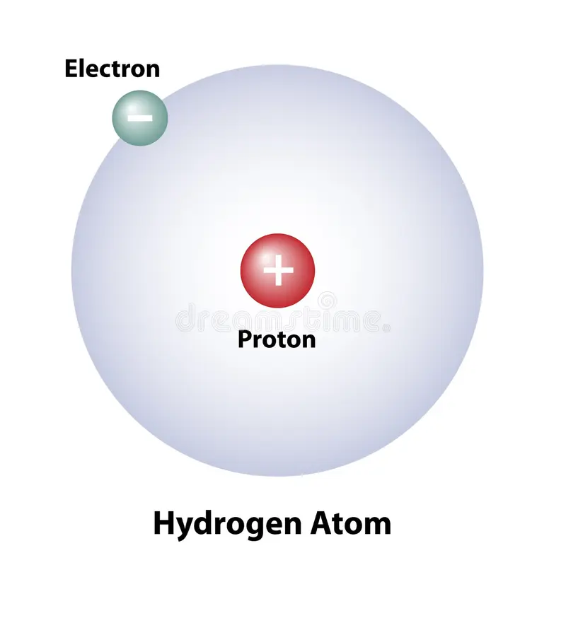

## 15.1 Static Charge

**Charge is measured in coulombs (C)**, named for the French physicist Charles A. de Coulomb (1736-1806), who discovered a relationship between electric force and charge.

Static charge refers to the accumulation of electric charges on the surface of an object. This phenomenon was first discovered when ancient Greeks noticed that amber, when rubbed with fur, could attract lightweight objects like straw. This discovery laid the foundation of electrostatics.

Example: When a silk cloth is rubbed with a glass rod, electrons are transferred from the glass rod to the silk, making the glass rod positively charged and the silk cloth negatively charged.

### Table: Basic Particles and Their Charges

| Particle | Charge (C) | Mass (kg) |
| --- | --- | --- |
| Electron | −1.6 × 10⁻¹⁹ C | 9.109 x 10-31 |
| Proton | +1.6 × 10⁻¹⁹ C | 1.673 x 10-27 |
| Neutron | 0 (neutral) | 1.675 x 10-27 |

The atom consists of a nucleus made up of protons and neutrons, with electrons revolving around it. Electrostatic properties arise due to the imbalance of protons and electrons.

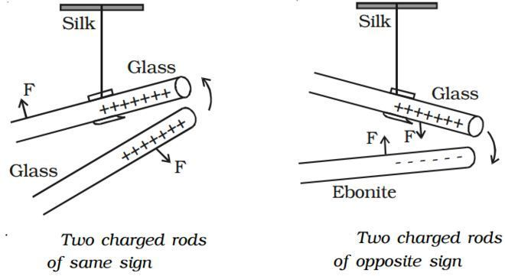

Experiment: Like charges repel each other while opposite charges attract. This can be shown by suspending charged pitch balls close to each other and observing their motion.

### 15.1.1 Charge is Conserved

Charge conservation states that electric charge can neither be created nor destroyed. The total charge in an isolated system remains constant, even though it may be redistributed among objects.

The excess charge is most commonly produced by a transfer of electrons, not protons. Protons are bound in the nucleus and, under most common situations, stay fixed.

'When a glass rod is rubbed with a silk cloth, both the glass rod and silk cloth become charged. The electrons from the glass rod move to the silk cloth, making the glass rod positively charged. At the same time, the silk cloth gains electrons and becomes negatively charged.

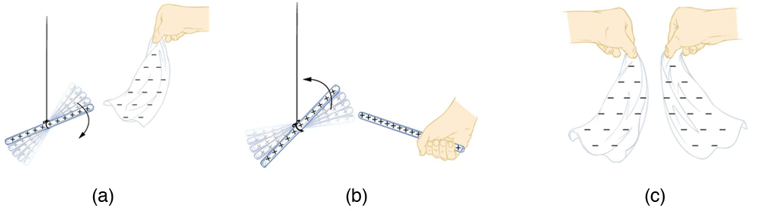

## 15.2 Conductors and Insulators

Conductors are distinguished from insulators by their capacity to conduct or transmit electric charge.

Conductors are materials that allow free movement of electrons due to their valence electrons being weakly bound. Examples include copper, silver, and aluminum. Insulators, on the other hand, have tightly bound electrons and thus do not allow the flow of electric charge. Examples include rubber, wood, and glass.

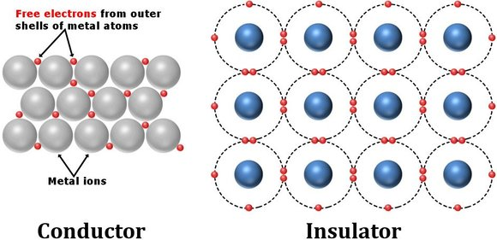

The free electron model explains that in conductors, valence electrons become delocalized and form an electron cloud, enabling conduction of electricity. In insulators, electrons are localized and resist flow.

Charge distribution depends on the material's nature. In conductors, charges reside on the surface, while in insulators they remain fixed in localized regions.

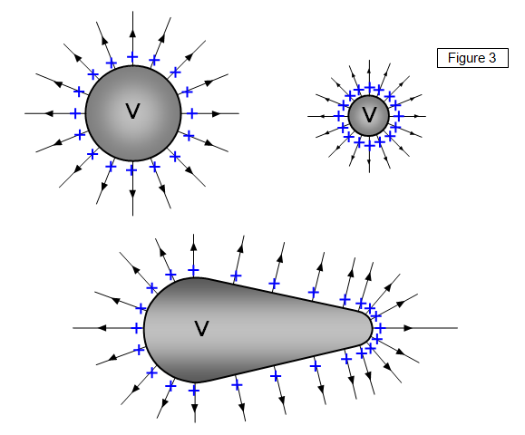

## 15.3 Charging and Discharging

Charging refers to the process of adding or removing electrons to an object, whereas discharging is the process of neutralizing an object by equalizing charges.

### 15.3.1 Charging by Friction

When two insulating materials are rubbed together, electrons transfer from one material to the other. The object losing electrons becomes positively charged, while the object gaining electrons becomes negatively charged.

Removing electrons ionizes the atom. The energy needed to remove the outermost electron is called ionization energy.

### 15.3.2 Charging by Contact (Conduction)

When a charged body is brought into direct contact with a neutral body, electrons are transferred until both bodies attain the same potential, leaving both charged.

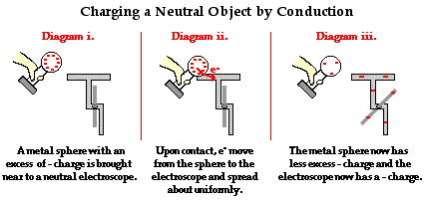

### 15.3.3 Charging by Induction

**A change in distribution of electrical charge in an object, caused by the influence of nearby charges is called electrostatic induction.**

Charging by induction occurs when a charged object is brought near a neutral conductor. The presence of the charged object redistributes electrons in the neutral conductor without direct contact.

Discharging can also be achieved by grounding, where excess charges flow to the earth through a conductor.

### 15.3.4 Methods to Discharge Insulators

Insulators can be discharged by the following methods:

A. Heating above flame: Increases molecular vibrations and releases charges.

B. Exposing to humid conditions: Moisture provides a conducting path for charges to dissipate.

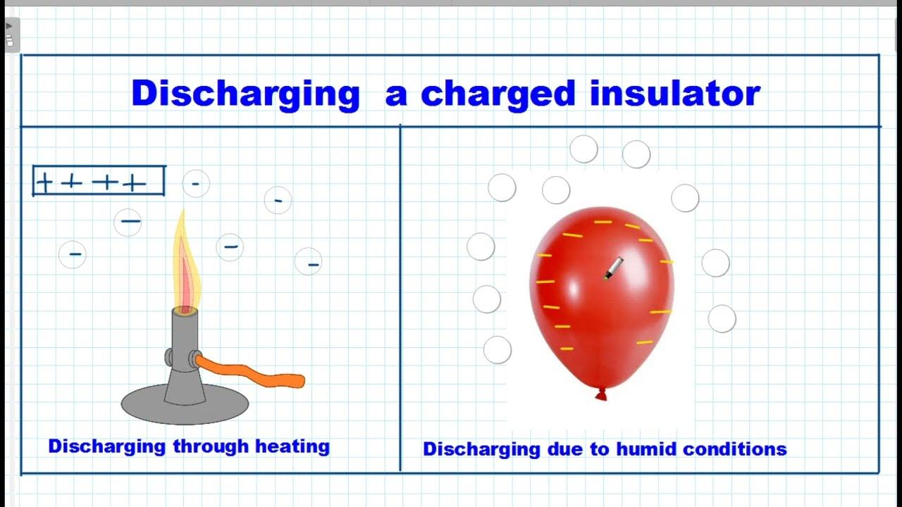

### 15.3.5 Surface Charge Can Be Induced on Insulators by Polarization

Polarization occurs when an external electric field displaces charges slightly within atoms or molecules of an insulator, inducing surface charges.

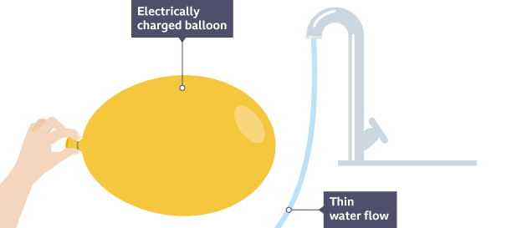

## 15.4 Electroscope

The electroscope is an essential device for detecting and analyzing the charge present on an object. It operates on the principle that like charges repel and vice versa.

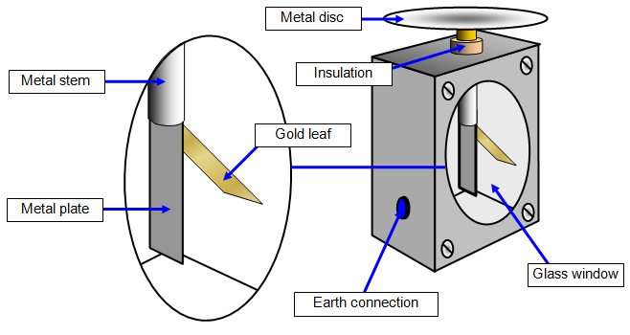

An electroscope is a device used to detect electric charge. It usually consists of a metal rod connected to thin gold leaves enclosed in a glass container. When charged, the leaves repel each other due to like charges.

To utilize the electroscope, we simply touch the metal disk with the object we wish to examine in order to detect its charge.

When a charged rod is brought near an electroscope, it shows that the rod is charged, but it doesn't indicate the charge's sign. However, if the electroscope is first given a known type of charge, the sign can be determined.

As a result, the leaf of the electroscope will diverge from the metal, indicating that it has been charged as shown in the figure below. If a negatively charged rod is brought close to the already negatively charged electroscope, the leaf will diverge even further as more electrons are repelled as shown in figure. On the other hand, a positively charged rod will attract electrons up to the bulb and away from the leaf area, causing the leaf to collapse as shown in figure

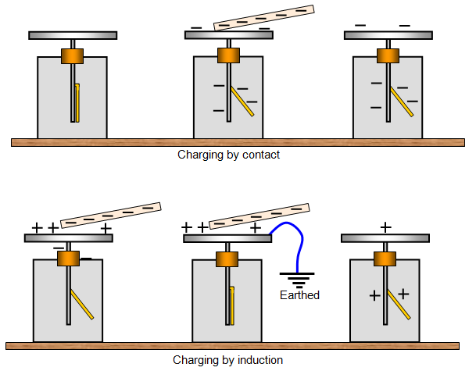

## 15.5 Electric Field

**The electrostatic force per test charge (unit positive charge) when it is brought to the - electric field of a source charge is called electric field intensity.**

Mathematically,

$E=\frac{F_{E}}{q_{0}}$, where

**E** is **electric field intensity**   
**F** is **force**, unit: **Newton (N)** and   
**q** is **charge**, unit **Coulomb (C)**

One charge exerts a force on another charge. This force is present everywhere around the charge, theoretically extending to infinity. The electric field is a region around a charged particle where another charge experiences a force.

The SI unit of electric field is **Newton per Coulomb (N/C)** or **Volt per meter (V/m)**.

Electric field intensity (electric field strength) is a vector quantity having both magnitude and direction. The direction of electric field intensity at a point will be the direction of force on a positive test charge at that point.

### 15.5.1 Electric Field Lines

Electric field lines are imaginary lines that represent the direction and strength of the electric field. They start from positive charges and end on negative charges. The closer the lines, the stronger the field.



These lines were first introduced by Michael Faraday. These lines are imaginary and have no physical existence.

For positive charge, the electric field lines or shortly field lines are directed away from positive charge because a positive charge will repel positive test charge as shown in figure. For negative charge, the field lines are directed towards the charge as it will attract a positive test charge when brought to its field as shown in figure.

In the figure below, the symmetric electric field lines for a pair of point charges with equal magnitude but opposite signs are shown, forming an electric dipole. The lines originate from the positive charge and terminate at the negative charge.

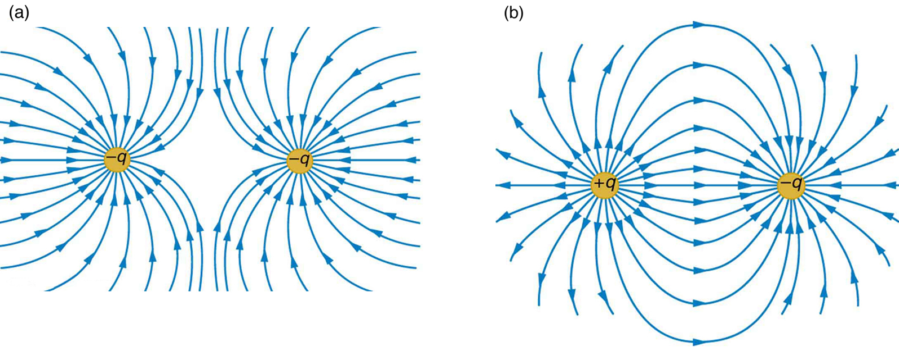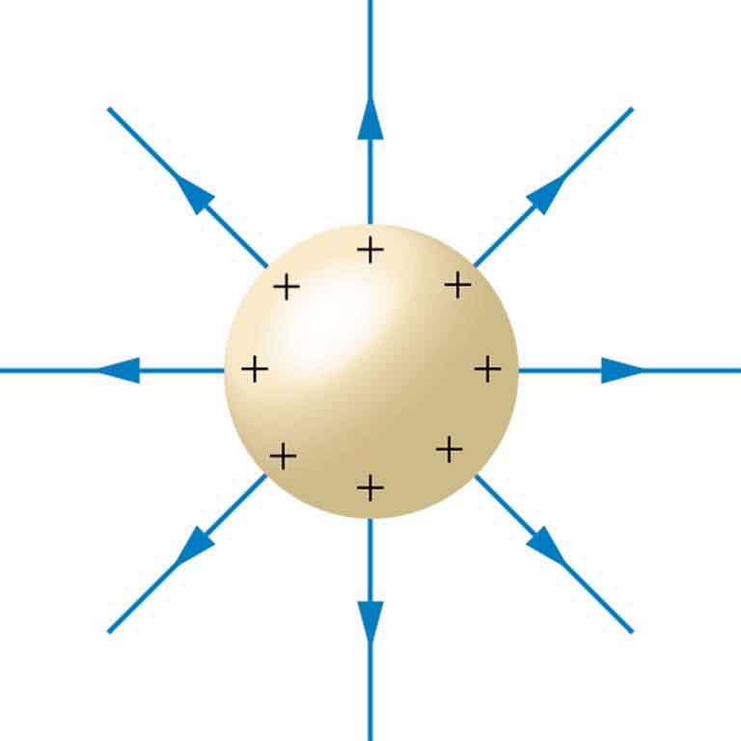

The electric fields of charged conductors have interesting properties. When studying electric fields, analyzing the field around a charged conducting sphere provides important insights. A charged conducting sphere generates an electric field that spreads out uniformly if it is positively charged.

When studying electric fields, an important example is two parallel plates that are oppositely charged. One plate has a positive charge, and the other has a negative charge. The electric field between these plates is shown in the figure below. The positive plate has a uniform positive charge, while the negative plate has a uniform negative charge, both created by connecting the plates to a battery. The electric field in this region is uniform, which means that both the strength and direction of the electric field remain constant throughout the space between the plates.

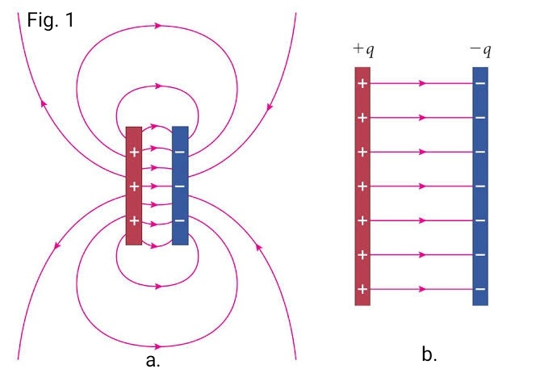

## 15.6 Applications of Electrostatics

### 15.6.1 Electrostatic Precipitator and Dust Extraction

Electrostatic precipitators are devices used to remove dust and smoke particles from industrial exhaust gases. To reduce air pollution, coal burning power stations use electrostatic precipitation phenomena to extract dust from the smoke in chimneys before releasing it to the environment.

High voltage electrodes charge the particles, which are then attracted to oppositely charged plates, thereby cleaning the air.

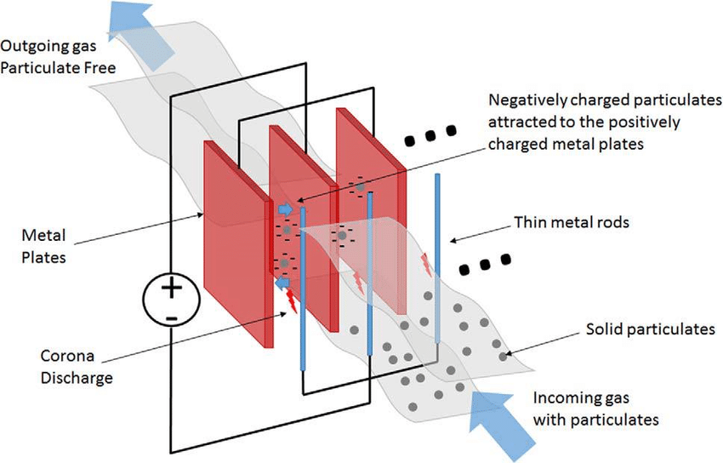

### 15.6.2 Photocopier Machine

A photocopier machine uses electrostatics and photoconductivity. A light image of the document is projected onto a photoconductive drum, causing the illuminated areas to lose charge. Toner particles adhere to the charged areas, and are then transferred to paper and fused using heat.

The major steps in this process include charging the photoconducting drum, transferring an image, creating a positive charge duplicate, attracting toner to the charged parts of the drum, and transferring the toner to the paper.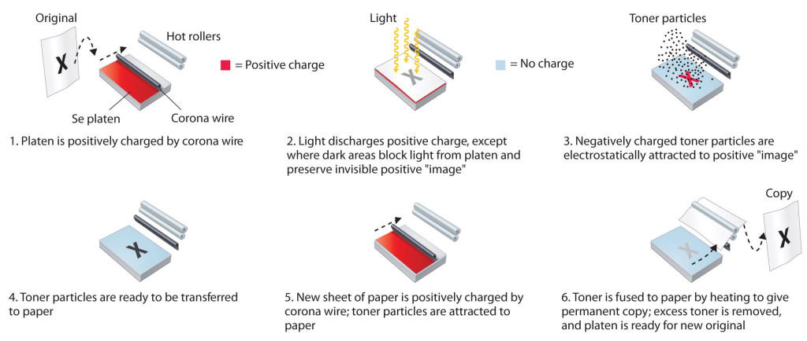

## 15.7 Electrical Breakdown

Insulating materials like rubber, glass, and some plastics typically do not conduct electricity. However, when the electric field is strong enough, they can reach a breakdown voltage, allowing electrons to be pulled from atoms and enabling current flow.

Electrical breakdown occurs when the electric field intensity exceeds the dielectric strength of a medium, causing it to become conductive.

### 15.7.1 Visible Examples

**Corona discharge:** A bluish glow appearing near high-voltage conductors due to ionization of air.

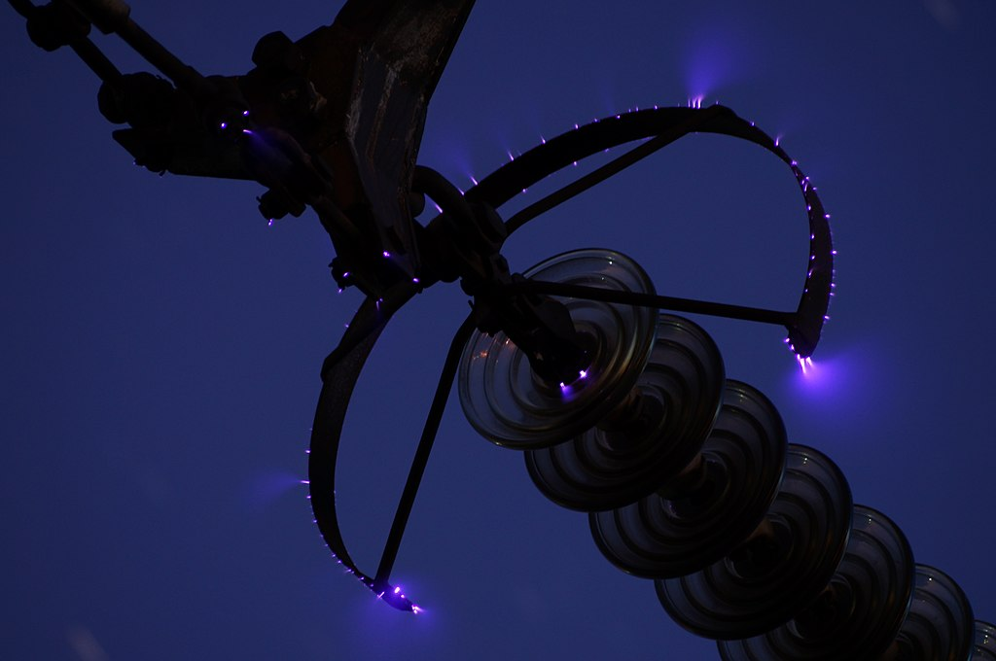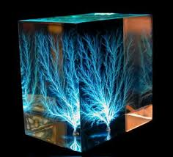

**Lichtenberg figures:** Tree-like patterns formed when dielectric materials are subjected to high voltage discharges. These figures are a visual representation of the path taken by the electric current as it propagates through the material, leaving behind permanent, tree-like patterns.

### 15.7.2 Lightning Generation

Lightning is a powerful release of electrical energy that occurs in clouds when air, water droplets, or volcanic ash collide, causing electrical charges to separate.

Lightning is caused by the separation of charges within clouds during thunderstorms. When the potential difference becomes large enough, a massive discharge occurs between clouds or between cloud and ground.

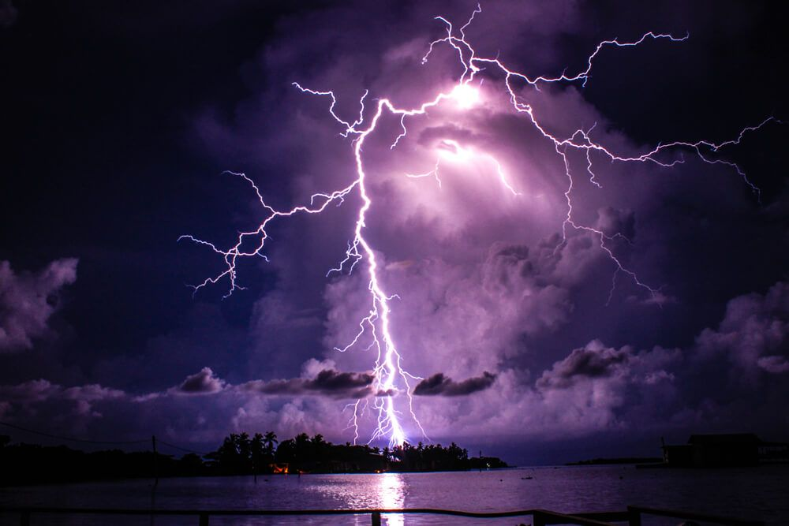

Positive charges rise to the top of the cloud, while negative charges sink. The Excess electrons at the cloud's base travel to the ground in a zigzag pattern called a step leader. The negative charge at the cloud's bottom induces a positive charge on the Earth's surface, creating a polarized effect. Nearby air molecules ionize and rise, forming a positive charge known as a streamer. When the streamer connects with the step leader, a complete path is established, resulting in a lightning strike, with the negative charge moving to the ground at speeds up to 100,000 km/s.

### 15.7.3 Varieties of Atmospheric Lightning

Different types of lightning include cloud-to-ground, cloud-to-cloud, and intra-cloud discharges. Other phenomena include ball lightning and sheet lightning.

Most lightning occurs entirely within a cloud (intracloud discharges), where it cannot be seen. However, visible discharges do to-ground place between clouds (cloud-to-cloud discharges) and between a cloud and the Earth (cloudhigh in discharges). Some examples include:

* **Sprites** - Short-lived, red flashes above thunderstorms.
* **Jets** - Narrow, upward bursts of blue light.
* **Elves** - Expanding rings of faint, white light.
* others with even more whimsical names - **Trolls, Pixies, Ghosts, Ball** **Lightning**.

### 15.7.4 Uncontrolled Electrical Charging

Uncontrolled electrical charging refers to the sudden discharge of accumulated charges in an unregulated manner, leading to damage or danger. Lightning rods are installed on tall structures to safely divert these discharges to the ground.

Lightning is destructive because it generates strong currents in poor conductors, creating extreme heat that can endanger buildings. A lightning rod, invented by Benjamin Franklin in the 1750s, helps protect structures. It consists of an appointed metal rod on a building, connected to a buried rod.



